Serial port tool terminator settings
Note: You only need to use one of the methods
Method 1
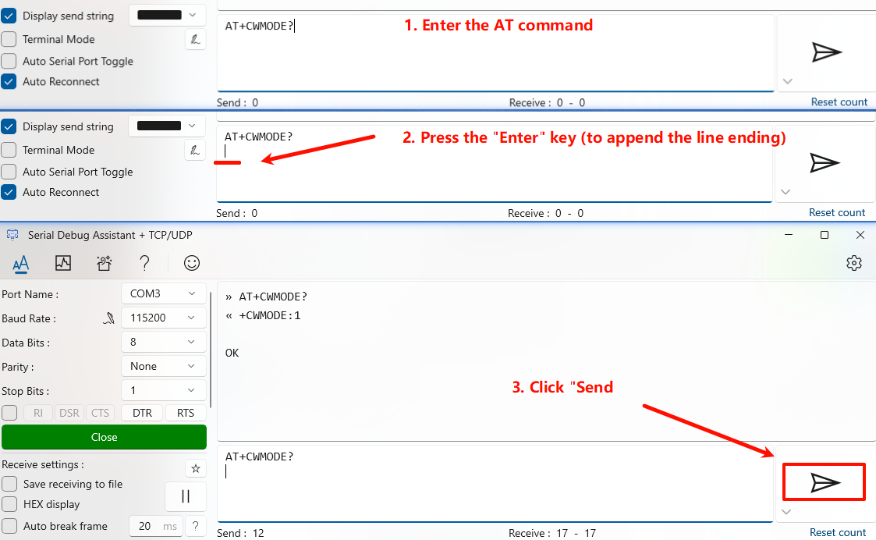
Method 2
